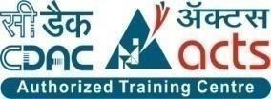

INSTITUTE FOR ADVANCED COMPUTING AND

SOFTWARE DEVELOPMENT AKURDI, PUNE

Documentation On

**E- Blood Bank**

PG-DAC MARCH 2023

**Submitted By:**

**Group No: 83**

| **Roll No.** | **Name:** |
| --- | --- |
| **233139** | **Ashwani Gupta** |
| **233176** | **Aishwarya Patil** |
| **Mr. Rohit Puranik** | **Mrs. Rupali Solaskar Thorat** |
| **Centre Coordinator** | **Project Guide** |

## ABSTRACT

Our project E- Blood Bank includes registration of users, storing their details into the system, and also booking their appointments for blood requirements.

Our application has the facility to give a unique id for every User and stores the details of every user and patient automatically. A registered user can make appointments and can see his past all appointments with status. The E-Blood Bank can be entered using a user name(email) and password. It is accessible either by an administrator or registered Users. All the given data will be stored into the database, that data can be retrieved easily. The interface is very user-friendly. The data are well protected for personal use and makes the data processing very fast.

It has mainly two modules. One is at Administration Level and other one is of User i.e. of admin and user. The Application maintains authentication in order to access the application. Administrator task includes managing user’s information, blood transaction information. To achieve this aim a database was designed one for the users and other for the blood transaction which the admin can access.

## 

## ACKNOWLEDGEMENT

Apart from the efforts of the team, the success of any project depends largely on the encouragement and guidelines of many others. We take this opportunity to express our gratitude to the people who have been instrumental in the successful completion of this project.

The completion of any inter-disciplinary project depends upon cooperation, coordination and combined efforts of several sources of knowledge.

We are eternally grateful to our guide Mrs. Rupali Solaskar Thorat for her even willingness to give us valuable advice and direction under which we executed this project. Her constant guidance and willingness to share her vast knowledge made us understand this project and its manifestations in great depths and helped us to complete the assigned tasks. . I extend my sincere thanks to our respected Centre Co-ordinator Mr. Rohit Puranik for allowing us to use the facilities available. I would like to thank the other faculty members also, at this occasion. Last but not the least, I would like to thank my friends and family for the support and encouragement they have given me during the course of our work.

**Ashwani Gupta(223139)**

**Aishwarya Patil (223176)**

**Table of Contents**

[ABSTRACT 2](#_Toc115257750)

[ACKNOWLEDGEMENT 3](#_Toc115257751)

[INTRODUCTION 6](#_Toc115257752)

[1.1 PROJECT OBJECTIVE 7](#_Toc115257753)

[1.2 PROJECT OVERVIEW 7](#_Toc115257754)

[1.3 PROJECT SCOPE 7](#_Toc115257755)

[1.4 STUDY OF THE SYSTEM 8](#_Toc115257756)

[1.4.1 MODULES: 8](#_Toc115257757)

[SYSTEM ANALYSIS 13](#_Toc115257758)

[2.1 EXISTING SYSTEM 13](#_Toc115257759)

[2.2 PROPOSED SYSTEM 13](#_Toc115257760)

[2.3 SYSTEM REQUIREMENT SPECIFICATION 14](#_Toc115257761)

[2.3.1 GENERAL DESCRIPTION 14](#_Toc115257762)

[2.3.2 SYSTEM OBJECTIVES 15](#_Toc115257763)

[2.3.3 SYSTEM REQUIREMENTS 15](#_Toc115257764)

[SYSTEM DESIGN 17](#_Toc115257765)

[3.1 INPUT AND OUTPUT DESIGN 17](#_Toc115257766)

[3.1.1 INPUT DESIGN: 17](#_Toc115257767)

[3.1.2 OUTPUT DESIGN: 18](#_Toc115257768)

[DATABASE DESIGN 18](#_Toc115257769)

[3.2 DATABASE 18](#_Toc115257770)

[3.3 SYSTEM TOOLS 18](#_Toc115257771)

[3.3.1 FRONT END: 18](#_Toc115257772)

[3.3.2 BACKEND: 19](#_Toc115257773)

[E-R Diagram: 22](#_Toc115257774)

[Class Diagram 23](#_Toc115257775)

[TABLE STRUCTURE: 24](#_Toc115257776)

[PROJECT DIAGRAM 28](#_Toc115257777)

[CONCLUSION 40](#_Toc115257778)

[REFERENCES 41](#_Toc115257779)

**LIST OF FIGURES**

**FIGURE 1: ADMIN ACTIVITY DIAGRAM ..............................................................................09**

**FIGURE 2: USER ACTIVITY DIAGRAM ..................................................................................11**

**FIGURE 3: LEVEL 2 ADMIN DFD ..............................................................................................20**

**FIGURE 4: LEVEL 2 USER DFD ..................................................................................................21**

**FIGURE 5: E-R DIAGRAM ............................................................................................................22**

**FIGURE 6: CLASS DIAGRAM ......................................................................................................23**

**FIGURE 7: TABLE STRUCTURE ................................................................................................ 24**

**FIGURE 8: PROJECT DIAGRAMS ..............................................................................................28**

## INTRODUCTION

The project E-Blood Bank includes registration of users, storing their details into the system. The software has the facility to give id for every user and stores the details of every user. Admin can manage blood stocks of a system and the details of a user.

The E-Blood Bank can be entered using a user id and password. It is accessible either by administrators or users. Only they can add data into the database. The data can be retrieved easily. The interface is very user-friendly. The data is well protected for personal use and makes the data processing very fast. The E-Blood Bank is powerful, flexible, and easy to use and is designed and developed to deliver real conceivable benefits to blood banks.

E-Blood Bank is designed for management purposes for blood banks, to cover a wide range of blood bank administration processes and day to day user appointments.

E-Blood Bank is a software product suite designed to improve the quality and management of blood bank management. E - Blood Bank enables you to develop your organization and improve its effectiveness and quality of work. Managing the key processes efficiently is critical to the success of the blood banks and helps you manage your processes.

## 1.1 PROJECT OBJECTIVE

1) Define Blood Bank functionalities

2) Recording information about the Users & Patients that come.

3) Generating computerized emails about status.

4) Recording information related to blood donations and consumptions

These are the various jobs that need to be done in a Blood Bank by the admins.

## 1.2 PROJECT OVERVIEW

Our application contains two modules – the Admin module and the User module. Our application will not only help the admin to preview the data but it will also allow them to edit, add or update records. The admin will be able to manage and update blood stocks users request for blood consumptions and user’s identity verification.

The user module can be accessed by both the Admins and the user itself. Admin can approve and/or Reject blood consumption appointments. Users will be able to create an appointment for blood requirements for a patient.

## 1.3 PROJECT SCOPE

E-Blood Bank will be always available for users where they can access the functionalities provided by the web application. The system provides secure registration and profile management facilities for users.

It will have adequate searching mechanisms to get information about blood bank related facilities. The system also provides an easy solution for the registered seekers to request a specific type of blood online using the internet and also allow donors to book the schedule online for the blood donation.

## 1.4 STUDY OF THE SYSTEM

### 1.4.1 MODULES:

The system after careful analysis has been identified to be presented with the following modules and roles. The modules involved are:

* Administrator
* Users

1.4.1.1 **Administrator:**

DESCRIPTION - The admin can add users, update user identity verification , update appointment status, create/update/delete events.

MAIN FLOW OF EVENTS

1. Admin logs in the system.
2. Admin can add users.

2.1 admin can fill the user’s details.

1. Admin maintains user’s record.

3.1 List of registered user’s details is displayed.

3.2 Admin can see/update the user’s ID proofs.

1. Admin View the blood stocks available and also can manage them.
2. Admin can approve or reject the blood consumption requests made by the users.
3. Admin can create events and manage and see them in a list form.

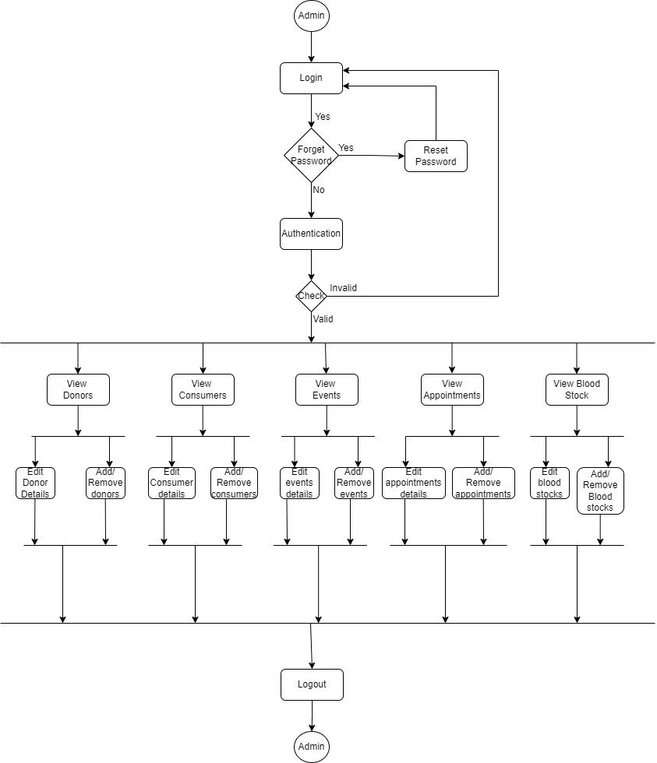

*Figure 1 Admin Activity Diagram*

* **Add user**

Admin can add new users and register him with details like name, Email, age, gender, Id card and its number etc.

* **Edit users**

Admin will have a list view of all the existing users. He can also edit for a particular user.

* **Add/Remove blood stock**

Admin can add /remove blood stocks form the inventory.

* **View blood donation history**

Admin will have a dashboard where he/she can view all the blood donation history.

* **Manage Events**

Admin can add new events and also can remove from them.

* **View all events**

Admin will have a list view of all the existing events. He/she can also edit for a particular event.

1.4.1.2 **Users:**

MAIN FLOW OF EVENTS

1. Users can sign up in the system.

2. Users can sign up by filling their details like name, Email, age, phone

Number , Id proof, Id number.

3. Users can view a list of all appointments.

4. Users view a list of Blood donations done by him/her.

PRE –CONDITION - Users must first log in with his/her credentials.

POST CONDITION - The EBB database is updated.

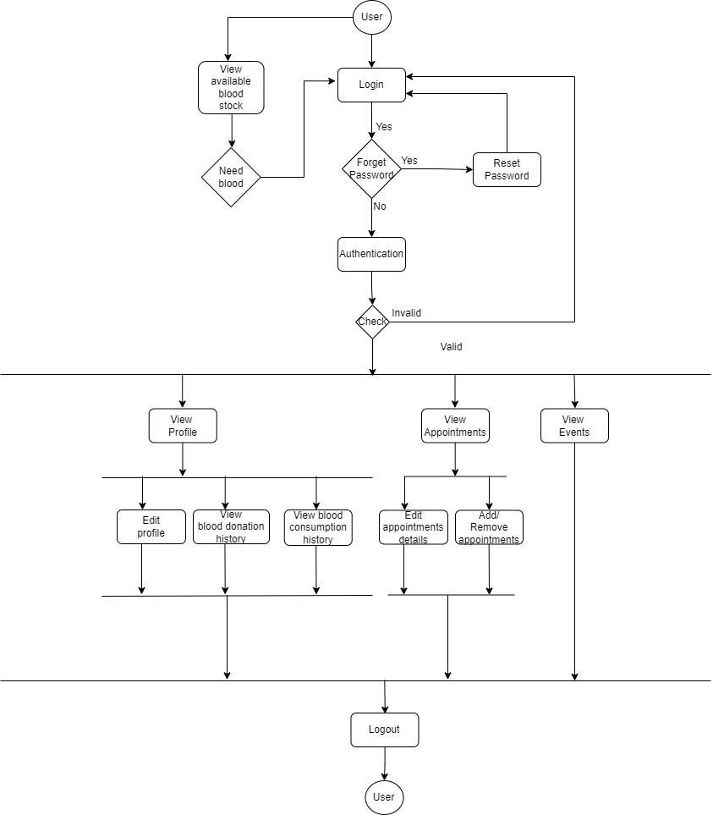

*Figure 2 User's Activity Diagram*

* **Add Addresses**

Users can add their multiple addresses by filing proper details.

* **List All Addresses**

Users will have a list view of all the Addresses of him/her.

* **List All Blood Donations**

Users will have a list view of all the donations done by him/her.

* **Book Appointments**

Users can book an appointment for the patient according to the blood group.

* **List All Appointments**

Users will have a list view of all the appointments generated by him/her.

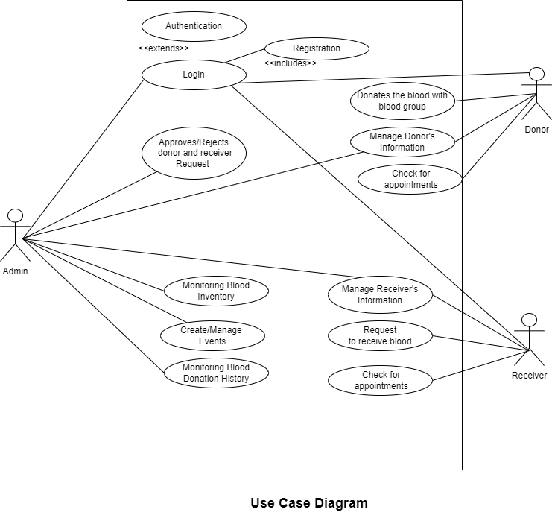

## SYSTEM ANALYSIS

System analysis is the process of gathering and interpreting facts, diagnosing problems, and using information to recommend improvements on the system. System analysis is a problem solving activity that requires intensive communication between the system users and system developers.

System analysis or study is an important phase of any system development process. The

system is viewed as a whole, the inputs are identified, and the system is subjected to close study

to identify the problem areas. The solutions are given as a proposal. The proposal is reviewed

on user request and suitable changes are made. This loop ends as soon as the user is satisfied

with the proposal.

## 2.1 EXISTING SYSTEM

In the existing system, Blood bank management functionalities are handled manually by

Blood bank staff by keeping the records of every donor and consumer in a register. There is no record present for billings of patients and no history is available for appointments.

* It is less user-friendly.
* It is difficult to know the user’s history.
* Difficult to maintain a user record.

## 2.2 PROPOSED SYSTEM

In the proposed system, we are developing a web application for blood bank

management. In which two modules have access to the system. The proposed system

allows to keep the record for every user and their blood consumptions. It will also have

all the records of users booking and appointments.

## 2.3 SYSTEM REQUIREMENT SPECIFICATION

### 2.3.1 GENERAL DESCRIPTION

**Product Description:**

BloodForLives is an online website, an outstanding way of bringing users on an online platform to provide blood bank related facilities in an efficient manner. This website provides an Interactive interface through which a user can interact with different areas of the application easily by maintaining the blood stocks as well as user’s information. EBB provides a simple interface and platform to ease the process of getting the information about blood availability online. It includes smooth functionality and efficiency that get the user’s work done. BloodForLives keeps the information about the blood stock and user data updated.

**Problem Statement:**

* Lack of immediate retrievals :

It is very difficult to retrieve information and to find particular information like- E.g. - To find out the user’s history, the admin has to go through various registers. This results in wastage of time.

* Lack of prompt updating :

Various changes to information like blood stocks history are difficult to make as paper work is involved.

* Error prone manual calculation:

By manual calculations error can be occur and take a lot of time this may result in incorrect information. For example calculation of available blood stocks based on various donations and consumptions.

* Preparation of accurate and prompt reports:

It is difficult task to collect information about patients from various register.

### 2.3.2 SYSTEM OBJECTIVES

➢ To provide a Web application for blood bank management

➢ To provide an web app for users to donate or consume blood easily.

### 2.3.3 SYSTEM REQUIREMENTS

**2.3.3.1 NON-FUNCTIONAL REQUIREMENTS**

Following Non-Functional Requirements will be there in the insurance to the internet:

* Secure access to Users confidential data.
* 24x7 availability.
* Better component design to get better performance at peak time.
* Various other Non-Functional requirements are:

1. **Security:**
   * System use shall not cause any harm to human users.
   * This web-based application will be password protected and any update of any entries of data will be carried out by privileged users.
   * System shall use a secured database.
   * Users can just read information but they cannot edit or modify anything except their personal information details. Only the System Administrator will do system administration and maintenance work.
2. **Data Integrity:**
   * All the data in the EBB must be accurate and reliable.
3. **Maintainability:**
   * OBBMS must have a high level of maintainability.
4. **Portability:**
   * The application must be easily portable on any system.
5. **Error Handling:**
   * The system should handle expected and unexpected errors in ways that prevent loss in information and long downtime periods.

**6)** **Serviceability:**

If any issue arises in the EBB, it should be programmed in such a way

that developers can service it again easily.

**2.3.3.2 FUNCTIONAL REQUIREMENTS**

**Admin:**

* **Database Management:**

Admin can control the database and keep track of all the records of consumers, donors and blood stock details.

* **User Details:**

Admin can view the personal details of the users.

* **Managing requests from Users:**

Admin will be responsible for approval and rejection of the requests made by the consumers and donor for getting the blood of required type and donation of the blood respectively.

* **View blood Stocks:**

Admin will keep track of blood’s stocks for the management purpose.

* **Organize a blood donation camp:**

Admin can organize a blood donation camp and he can assign the dates and centres for the blood donation camp.

* **Login & Logout:**

Admin will have to login to monitor and perform the functions mentioned above. Admin can logout after completion of his work

**User:**

* **Login:**

For blood transaction, user needs to get authenticated by logging in to the EBB web application by using their registered email ID and password.

* **Blood donation:**

After registering themselves into the system the user can donate as well as consume blood.

* **Blood Consumption:**

Users will have to make an appointment/request to get the blood from the blood bank. The user then can visit the blood bank to get the blood.

* **View profile:**

users can see the donations he/she has done in the past in the form of donation history. Also they can edit/update his/her profile.

* **Logout:**

After getting an appointment/request, the users can logout himself.

## SYSTEM DESIGN

System design is the solution for the creation of a new system. This phase focuses on the detailed implementation of the feasible system. Its emphasis on translating design specifications to performance specification. System design has two phases of development.

* Logical Design
* Physical Design

During logical design phase the analyst describes inputs (sources), outputs (destinations), databases (data sores) and procedures (data flows) all in a format that meets the user requirements. The analyst also specifies the needs of the user at a level that virtually determines the information flow in and out of the system and the data resources. Here the logical design is done through data flow diagrams and database design. The physical design is followed by physical design or coding. Physical design produces the working system by defining the design specifications, which specify exactly what the candidate system must do. The programmers write the necessary programs that accept input from the user, perform necessary processing on accepted data and produce the required report on a hard copy or display it on the screen.

## 3.1 INPUT AND OUTPUT DESIGN

### 3.1.1 INPUT DESIGN:

Input design is the link that ties the information system into the world of its users. The input design involves determining the inputs, validating the data, minimizing the data entry and provides a multi-user facility. Inaccurate inputs are the most common cause of errors in data processing. Errors entered by the data entry operators can be controlled by input design. The user-originated inputs are converted to a computer-based format in the input design. Input data are collected and organized into groups of similar data. Once identified, the appropriate input media are selected for processing. All the input data are validated and if any data violates any conditions, the user is warned by a message. If the data satisfies all the conditions, it is transferred to the appropriate tables in the database. In this project the student details are to be entered at the time of registration. A page is designed for this purpose which is user friendly and easy to use. The design is done such that users get appropriate messages when exceptions occur.

### 3.1.2 OUTPUT DESIGN:

Computer output is the most important and direct source of information to the user. Output design is a very important phase since the output needs to be in an efficient manner. Efficient and intelligible output design improves the system relationship with the user and helps in decision making. Allowing the user to view the sample screen is important because the user is the ultimate judge of the quality of output. The output module of this system is the selected notifications.

## DATABASE DESIGN

## 3.2 DATABASE

Databases are the storehouses of data used in the software systems. The data is stored in tables inside the database. Several tables are created for the manipulation of the data for the system. Two essential settings for a database are

* Primary key - the field that is unique for all the record occurrences
* Foreign key - the field used to set relation between tables

Normalization is a technique to avoid redundancy in the tables.

## 3.3 SYSTEM TOOLS

The various system tools that have been used in developing both the front end and the back end of the project are being discussed in this chapter.

### 3.3.1 FRONT END:

React is a library which is developed by Face book is utilized to implement the frontend. React (also known as React.js or React JS) is a [free and open-source](https://en.wikipedia.org/wiki/Free_and_open-source_software) [front-end](https://en.wikipedia.org/wiki/Front_end_and_back_end) [JavaScript library](https://en.wikipedia.org/wiki/JavaScript_library) for building [user interfaces o](https://en.wikipedia.org/wiki/User_interfaces)r UI components. It is maintained by [Face book a](https://en.wikipedia.org/wiki/Facebook%2C_Inc)nd a community of individual developers and companies. React can be used as a base in the development of [single page o](https://en.wikipedia.org/wiki/Single-page_application)r mobile applications. However, React is only concerned with state management and rendering that state to the [DOM,](https://en.wikipedia.org/wiki/Document_Object_Model) so creating React applications usually requires the use of additional libraries for routing, as well as certain client-side functionality.

### 

### 3.3.2 BACKEND:

The back end is implemented using MySQL which is used to design databases. **MySQL:**

MySQL is the world's second most widely used open-source relational database management system (RDBMS). The SQL phrase stands for Structured Query Language. Application software called Navicert was used to design the tables in MySQL.

**Spring-Boot:**

This is used to connect MYSQL and fetch data from database and store the data in database. The Spring Framework is a[n application framework a](https://en.wikipedia.org/wiki/Application_framework)nd [inversion of control](https://en.wikipedia.org/wiki/Inversion_of_control) [container f](https://en.wikipedia.org/wiki/Servlet_container)or the [Java platform. T](https://en.wikipedia.org/wiki/Java_platform)he framework's core features can be used by any Java application, but there are extensions for building web applications on top of the [Java EE (](https://en.wikipedia.org/wiki/Java_EE)Enterprise Edition) platform. Although the framework does not impose any specific [programming model,](https://en.wikipedia.org/wiki/Programming_model) it has become popular in the Java community as an addition to the [Enterprise JavaBeans (](https://en.wikipedia.org/wiki/Enterprise_JavaBeans)EJB) model. The Spring Framework is Open-source Framework.

# D:\Cdac\Project\Documentation\Umls\DFD\DFD_lvl_2(Admin).jpg

*Figure 3 Level 2 DFD for Admin*

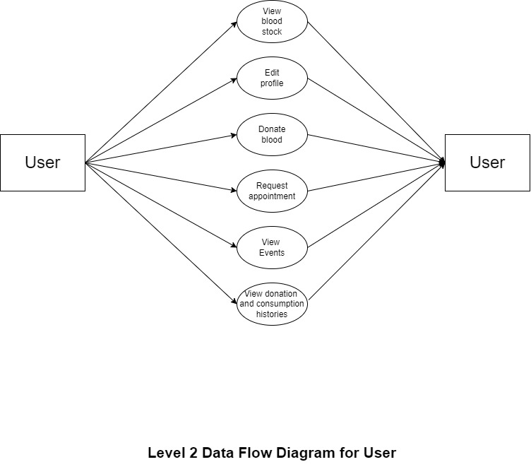

***Figure 4 2 Level DFD for User***

# E-R Diagram:

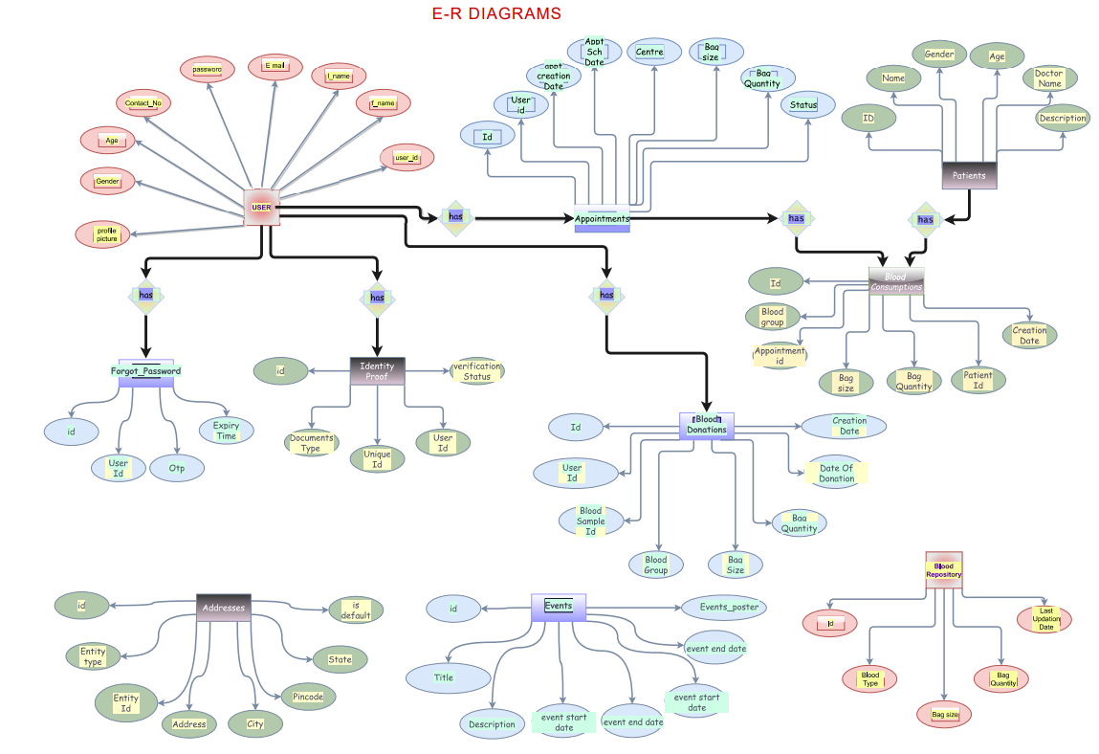

***Figure 5 E-R Diagram***

# Class Diagram

**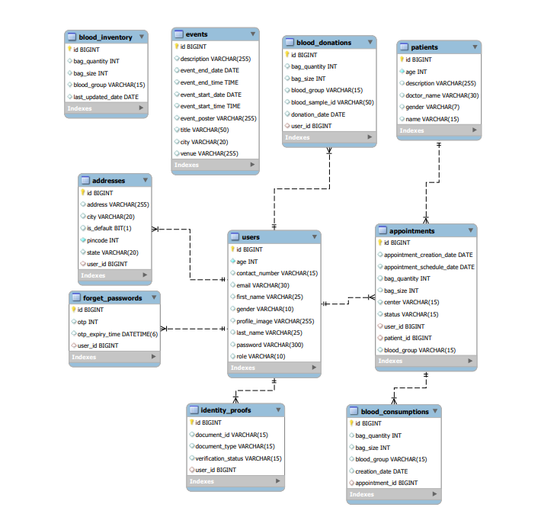**

***Figure 6 Class Diagram***

# TABLE STRUCTURE:

**Users:**

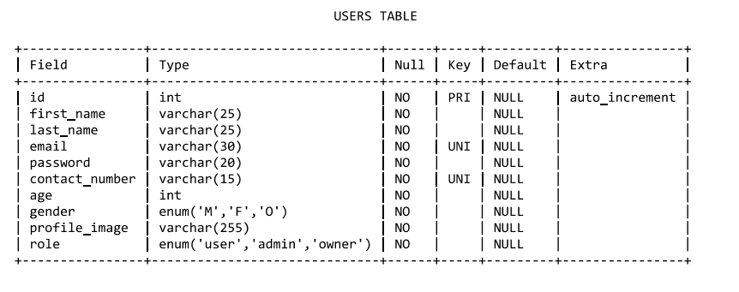

**Addresses:**

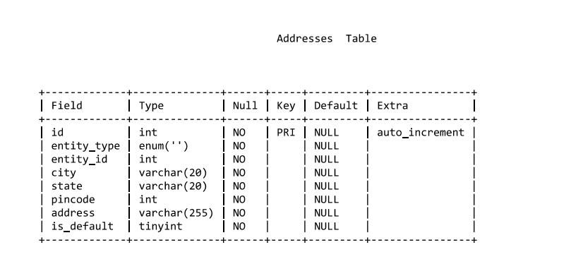

**Events: 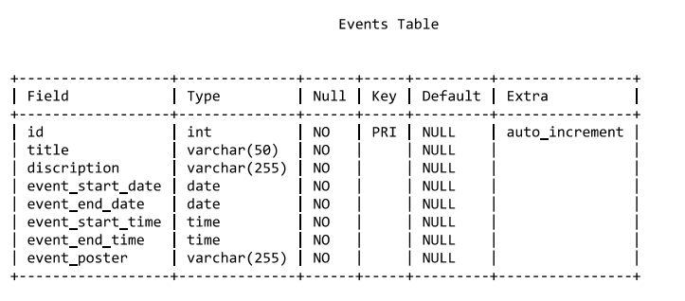**

**Forgot password:**

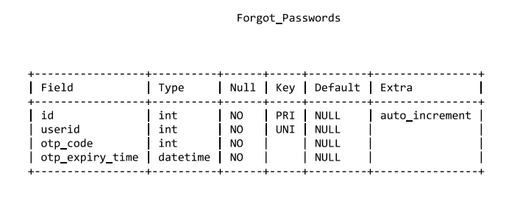

**Identity proofs:**

**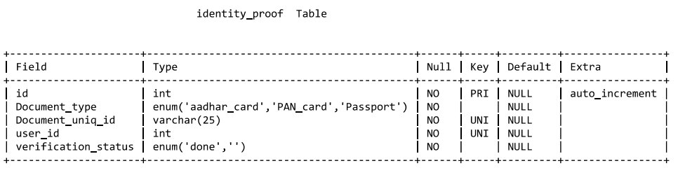**

**Blood inventory:**

**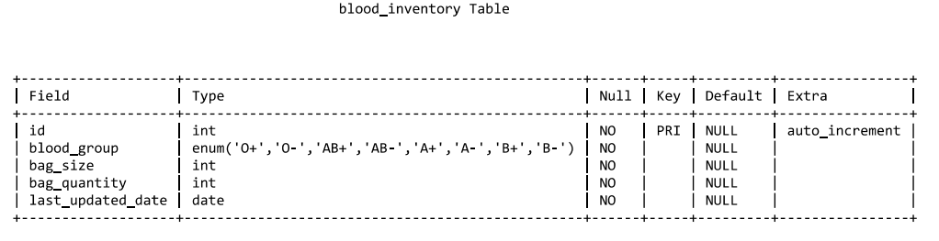**

**Appointments:**

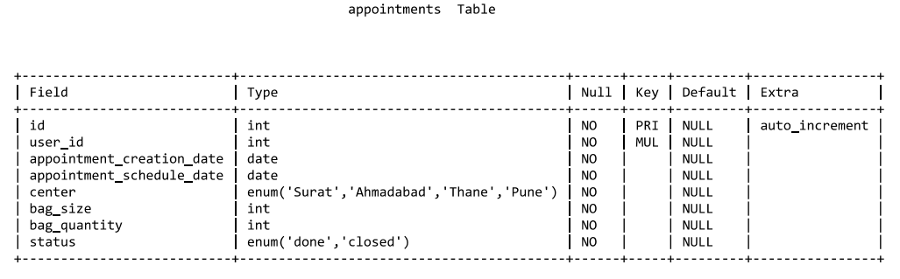

**patients:**

**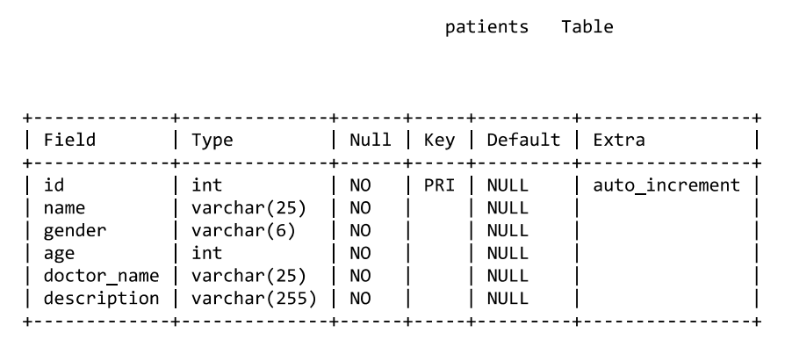**

**Blood consumptions:**

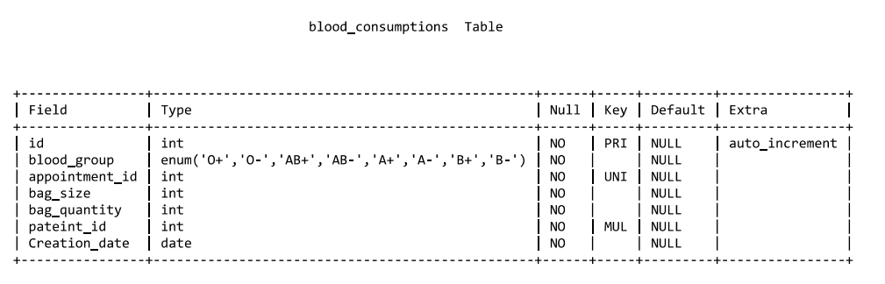

**Blood donation:**

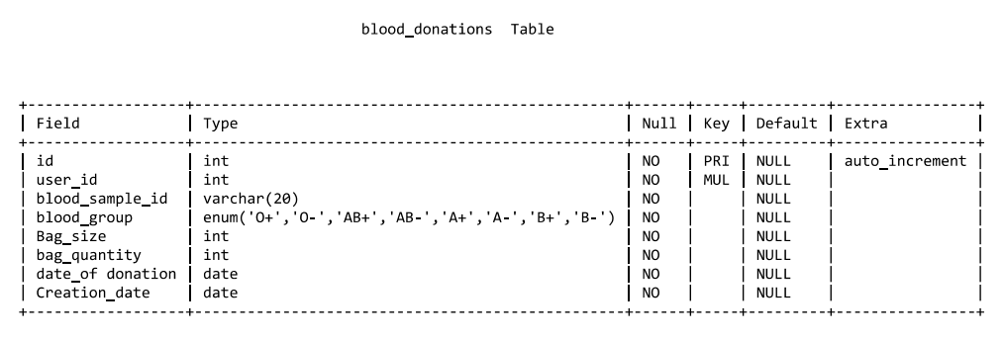

# PROJECT DIAGRAM

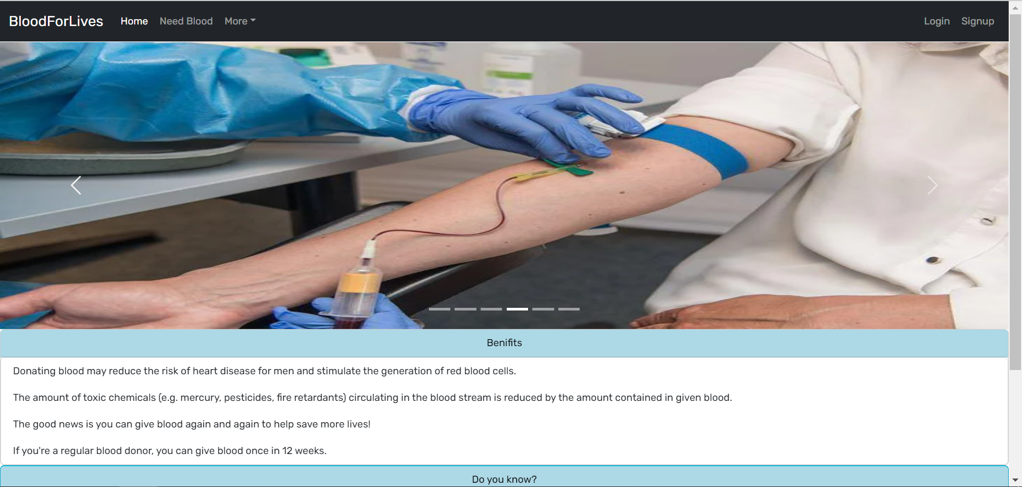

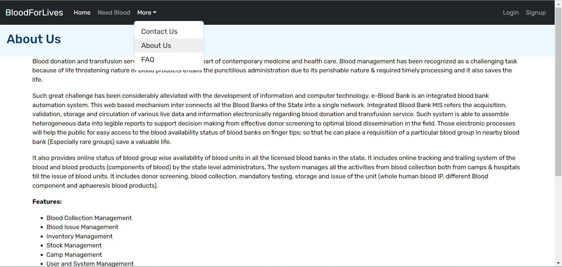

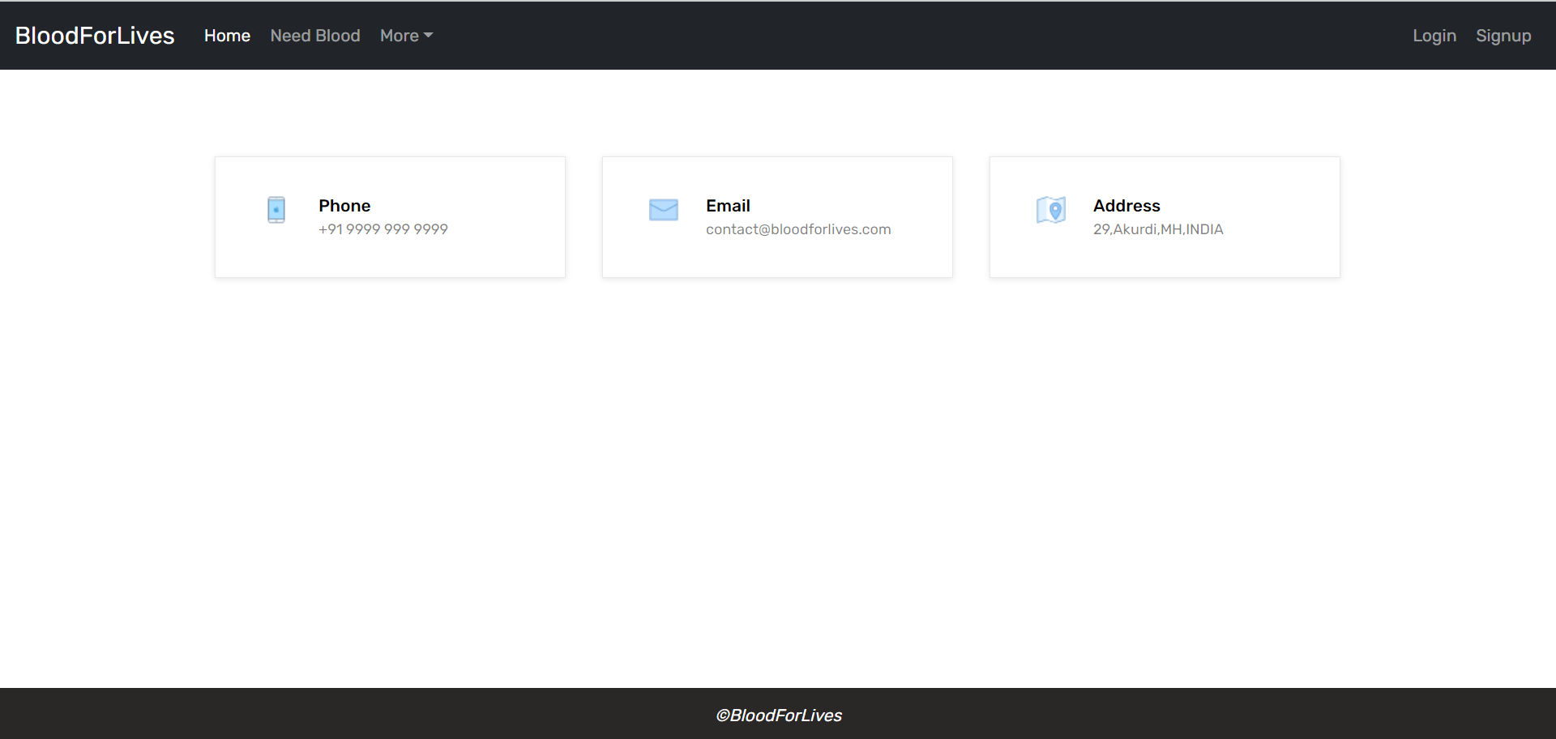

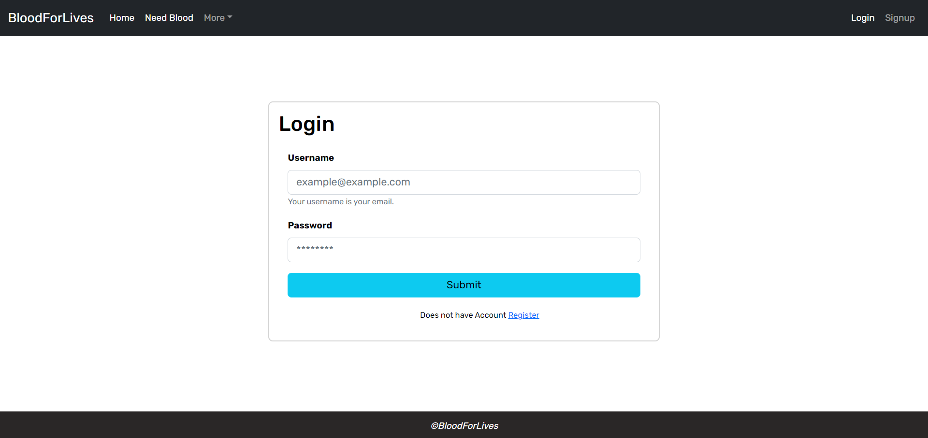

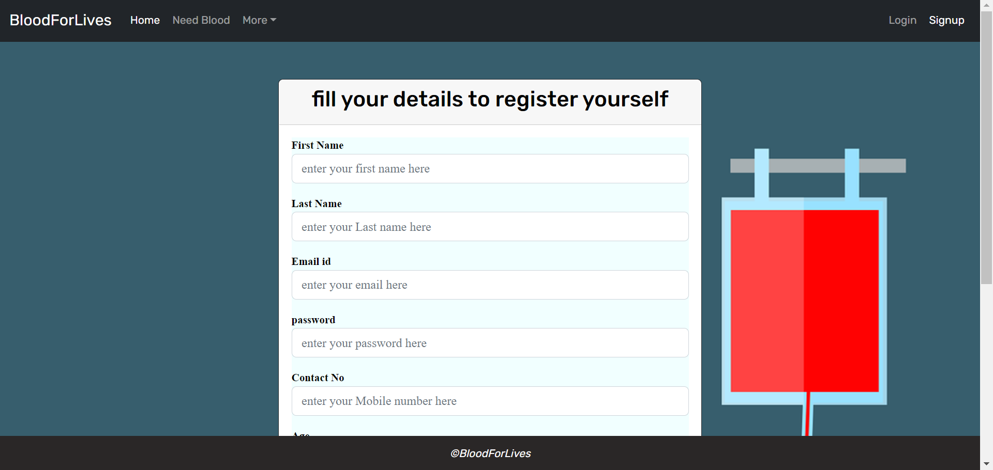

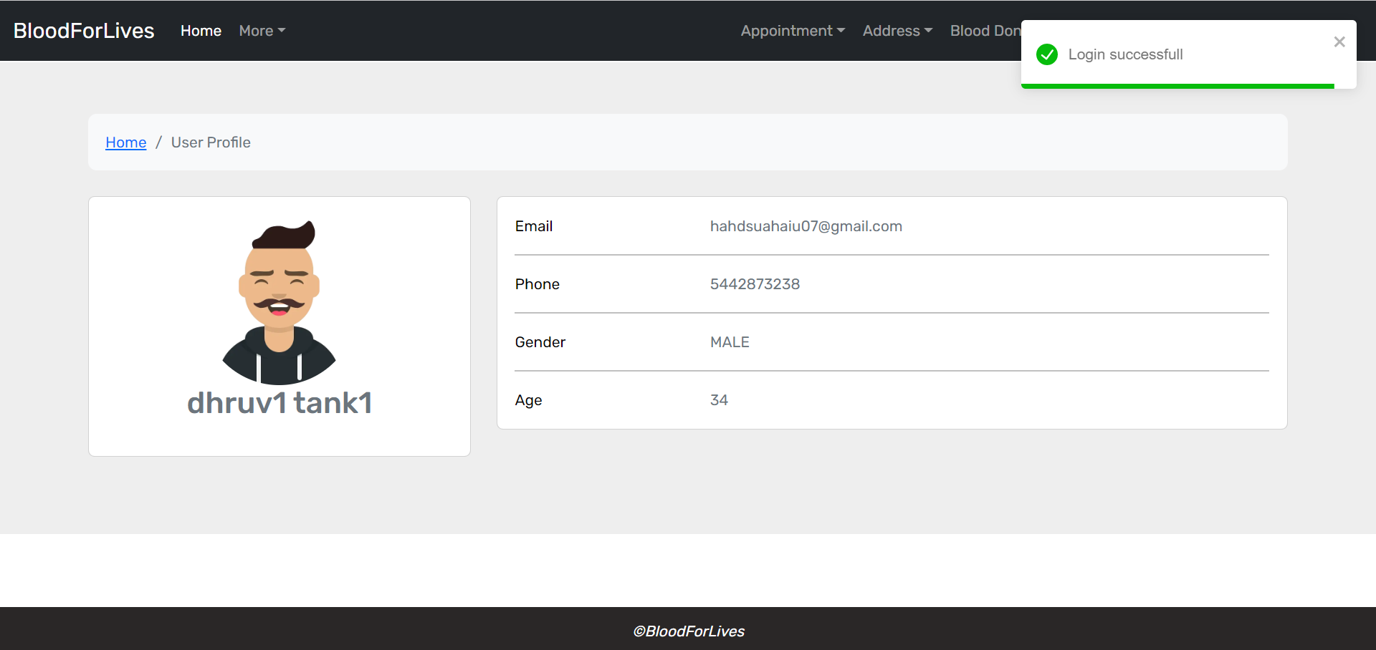

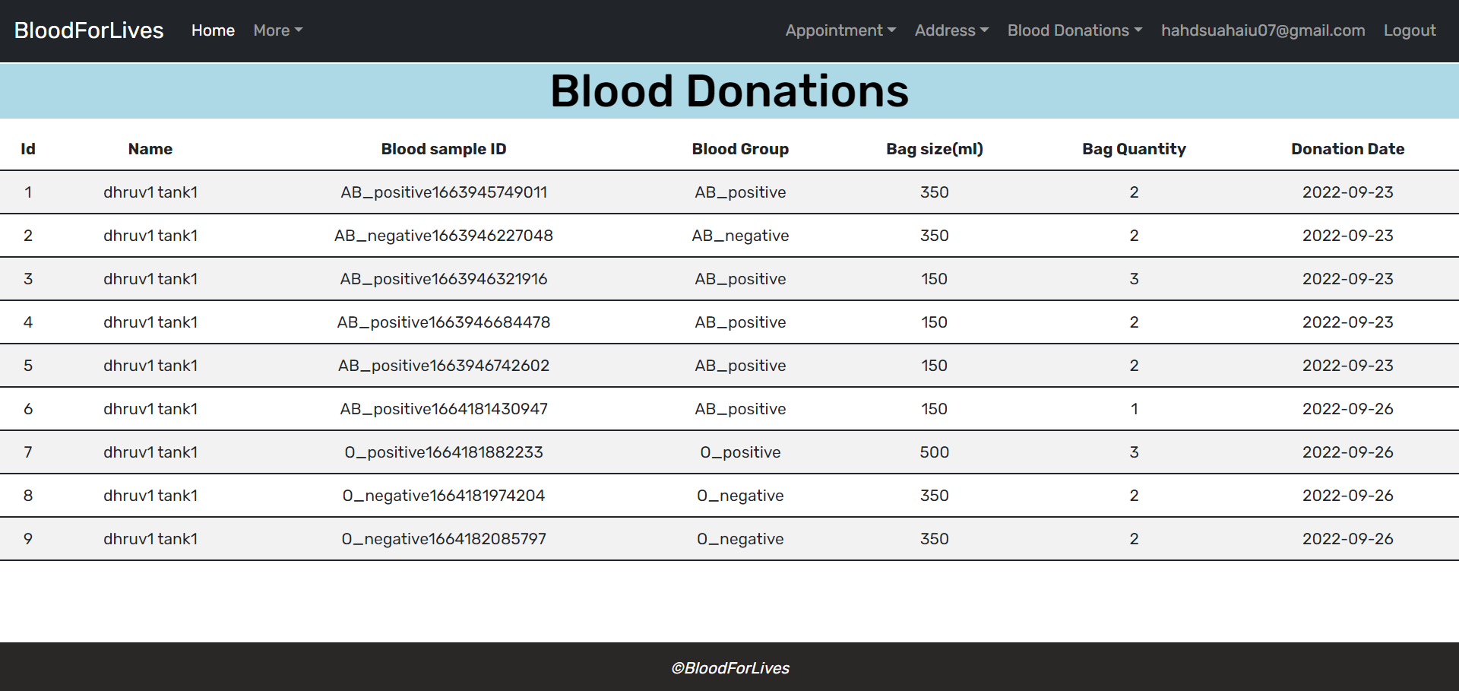

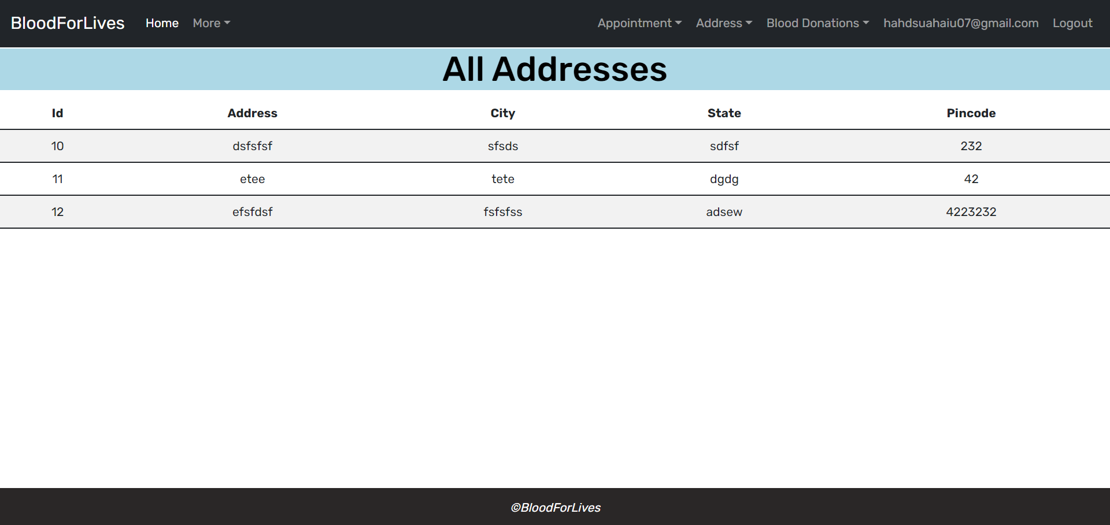

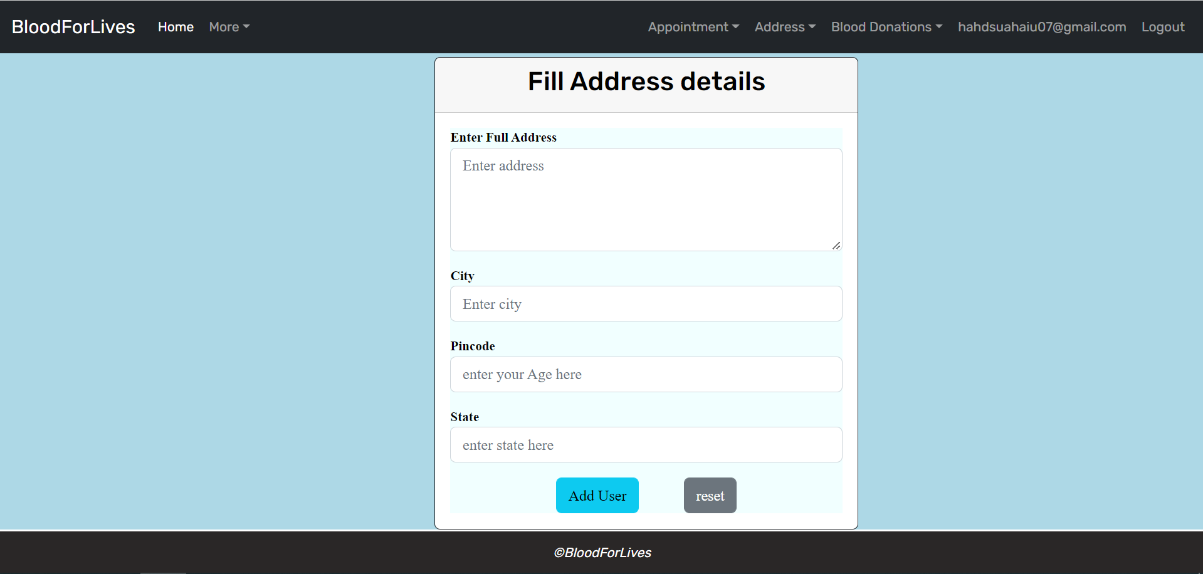

**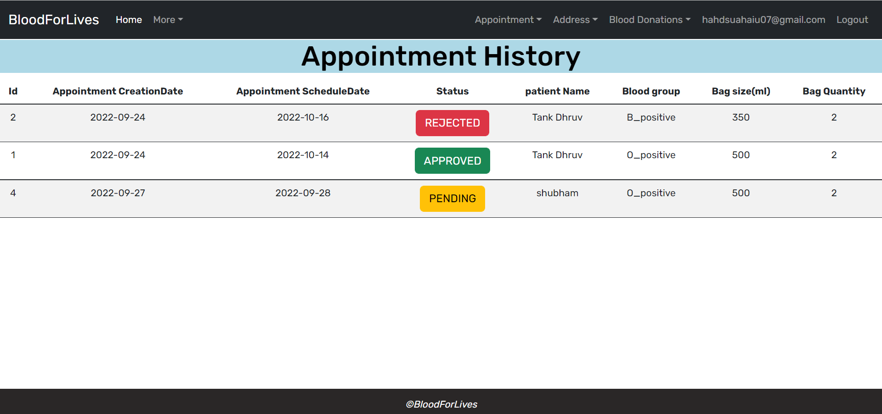**

**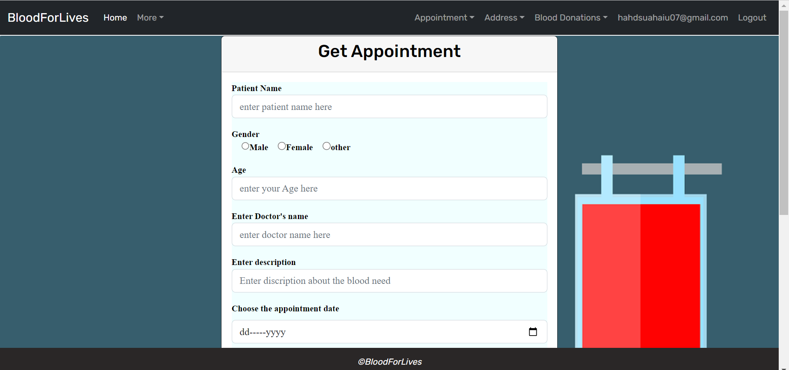**

**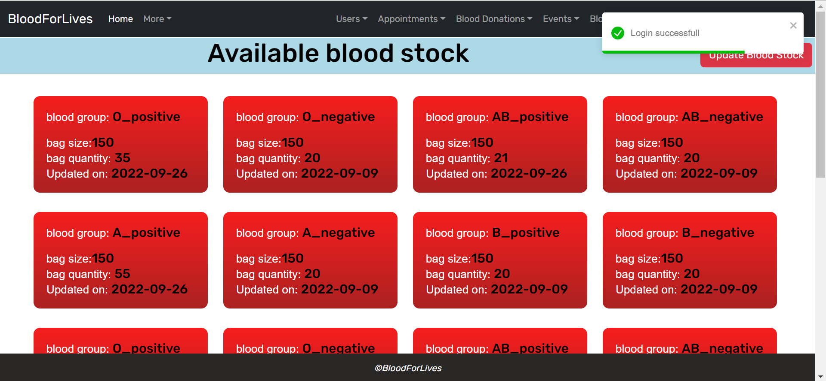**

**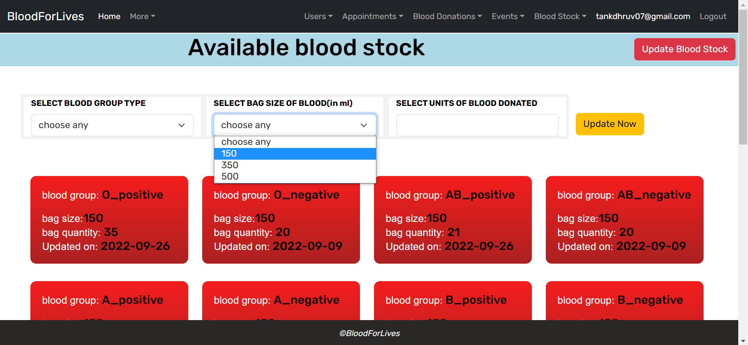**

**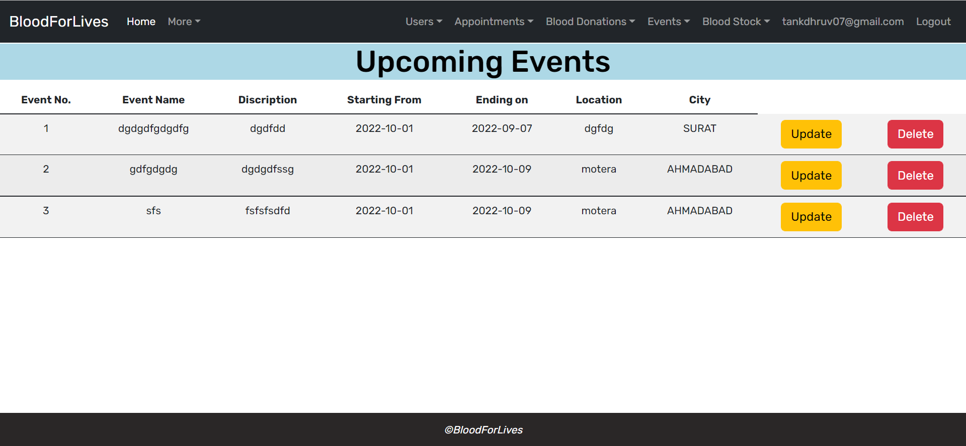**

**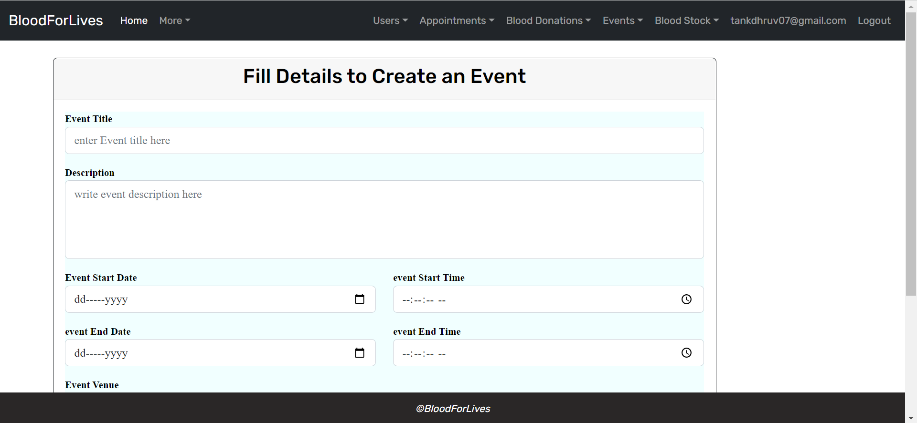**

**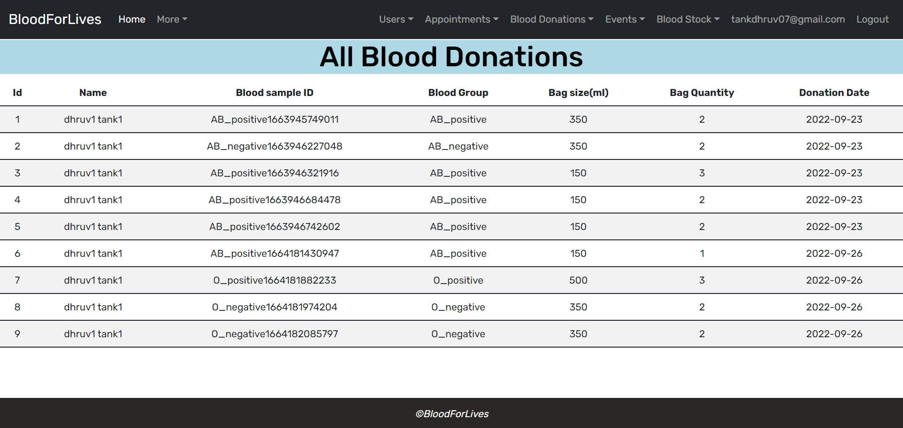**

**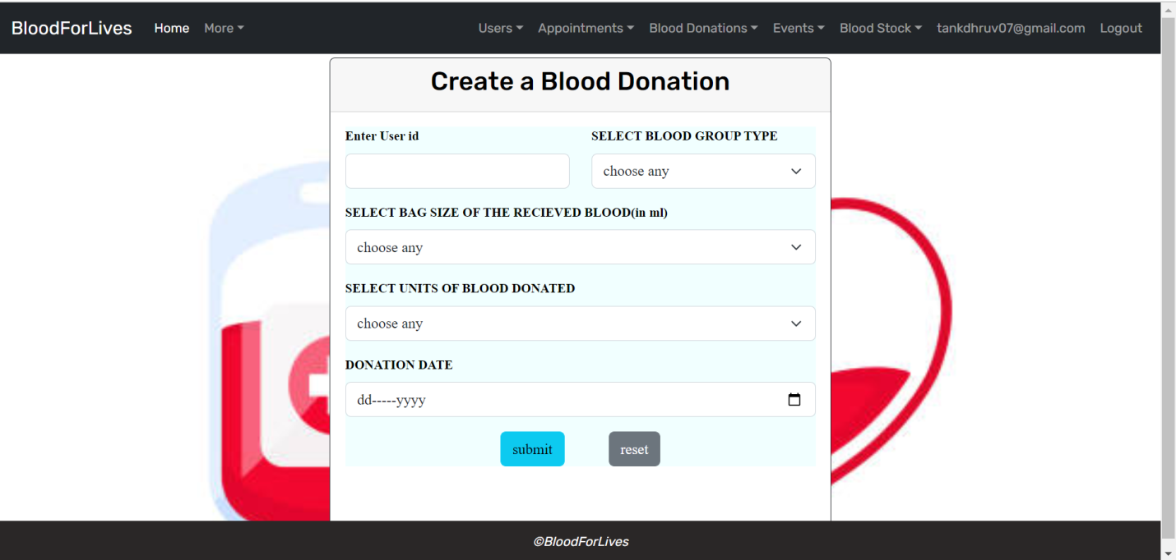**

**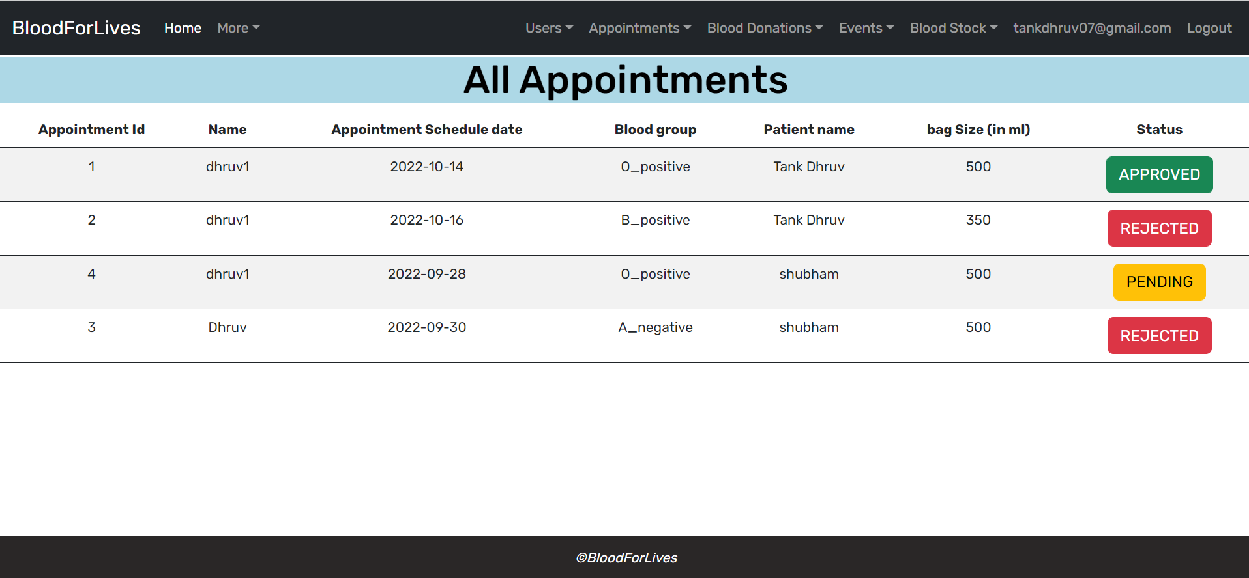**

**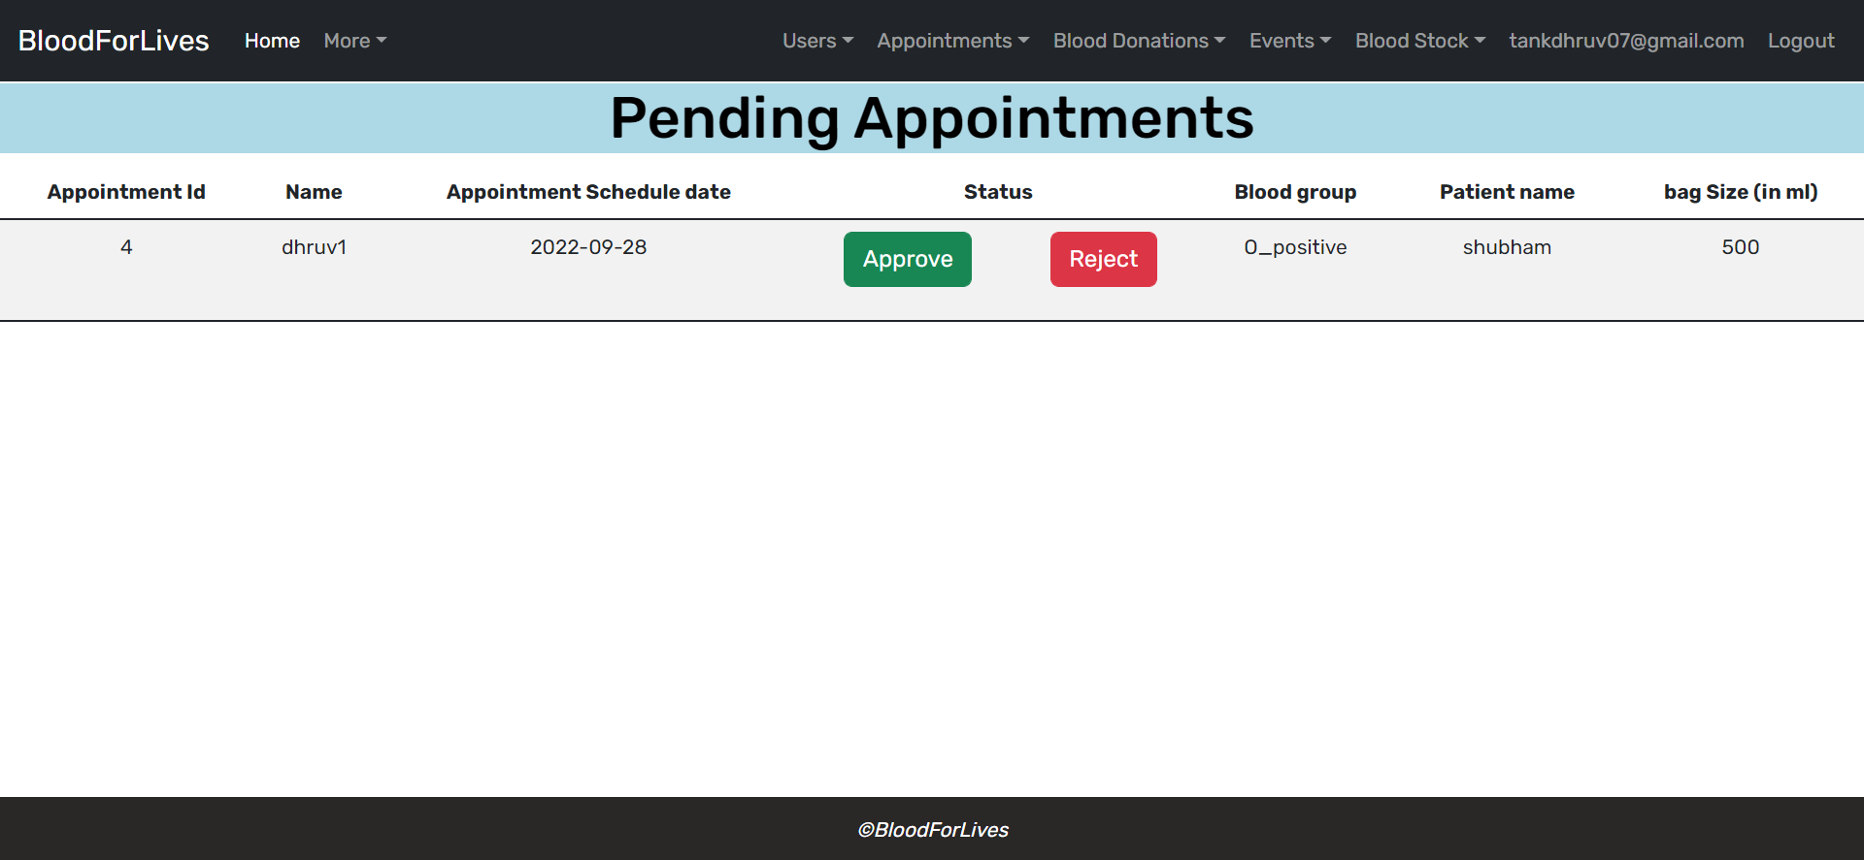**

**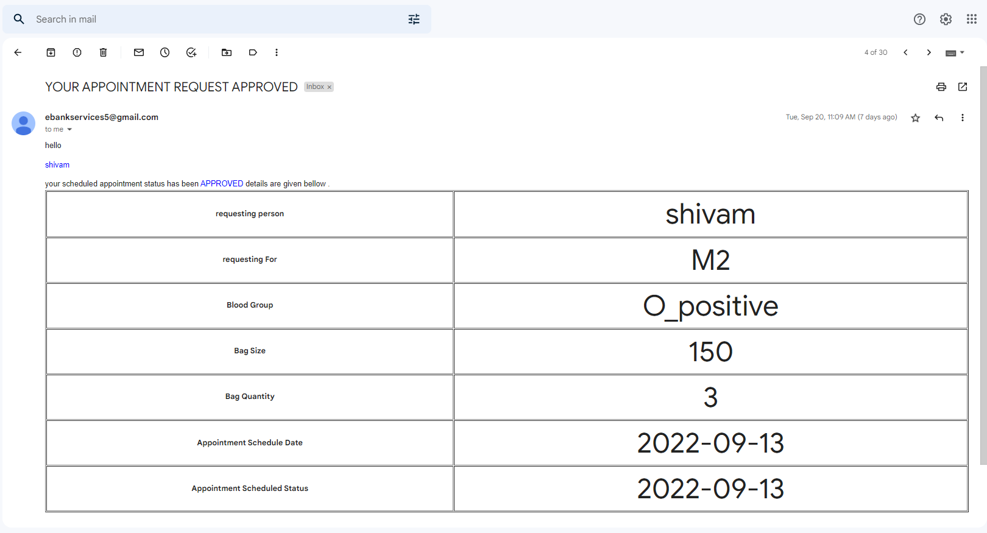**

**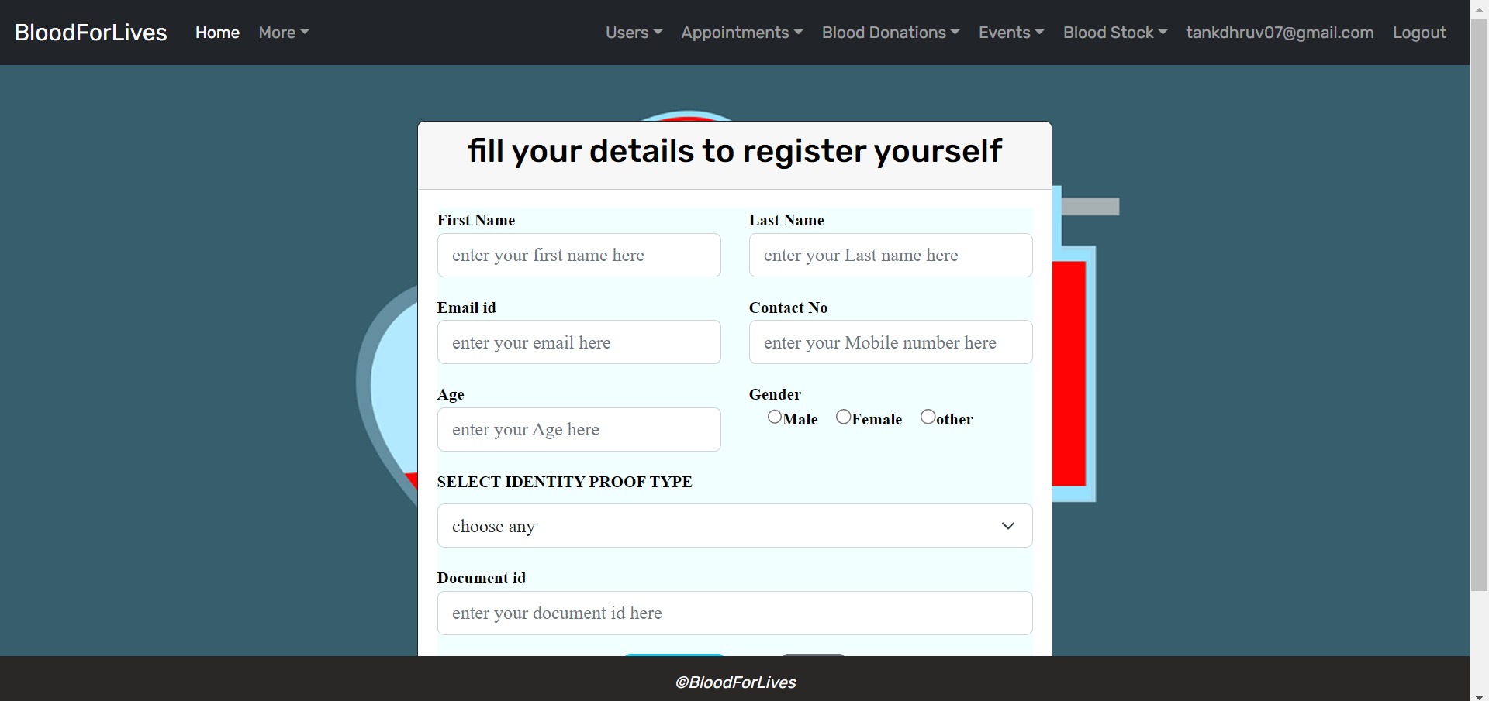**

**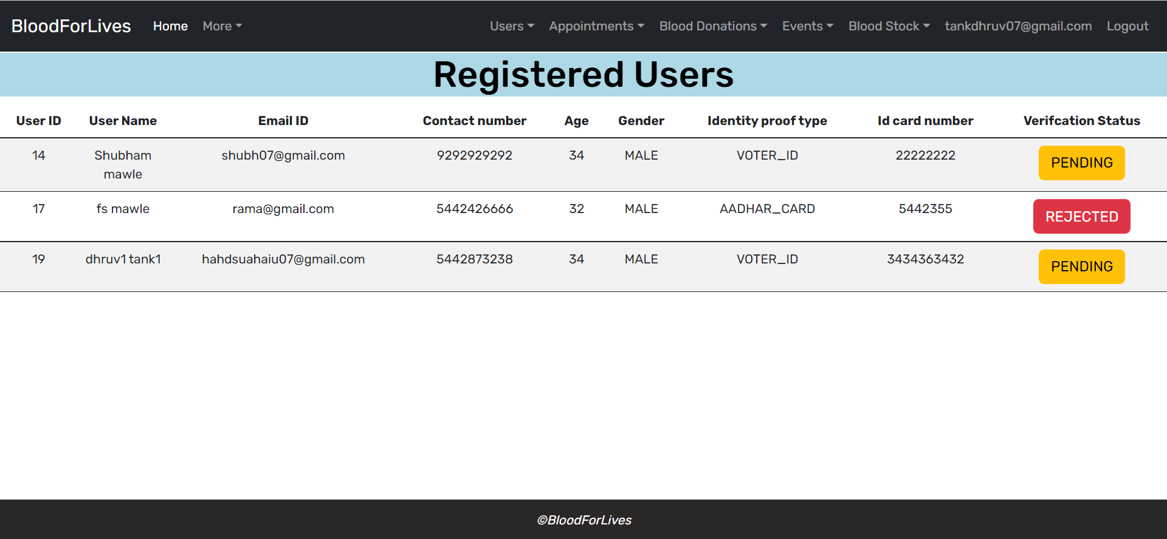**

**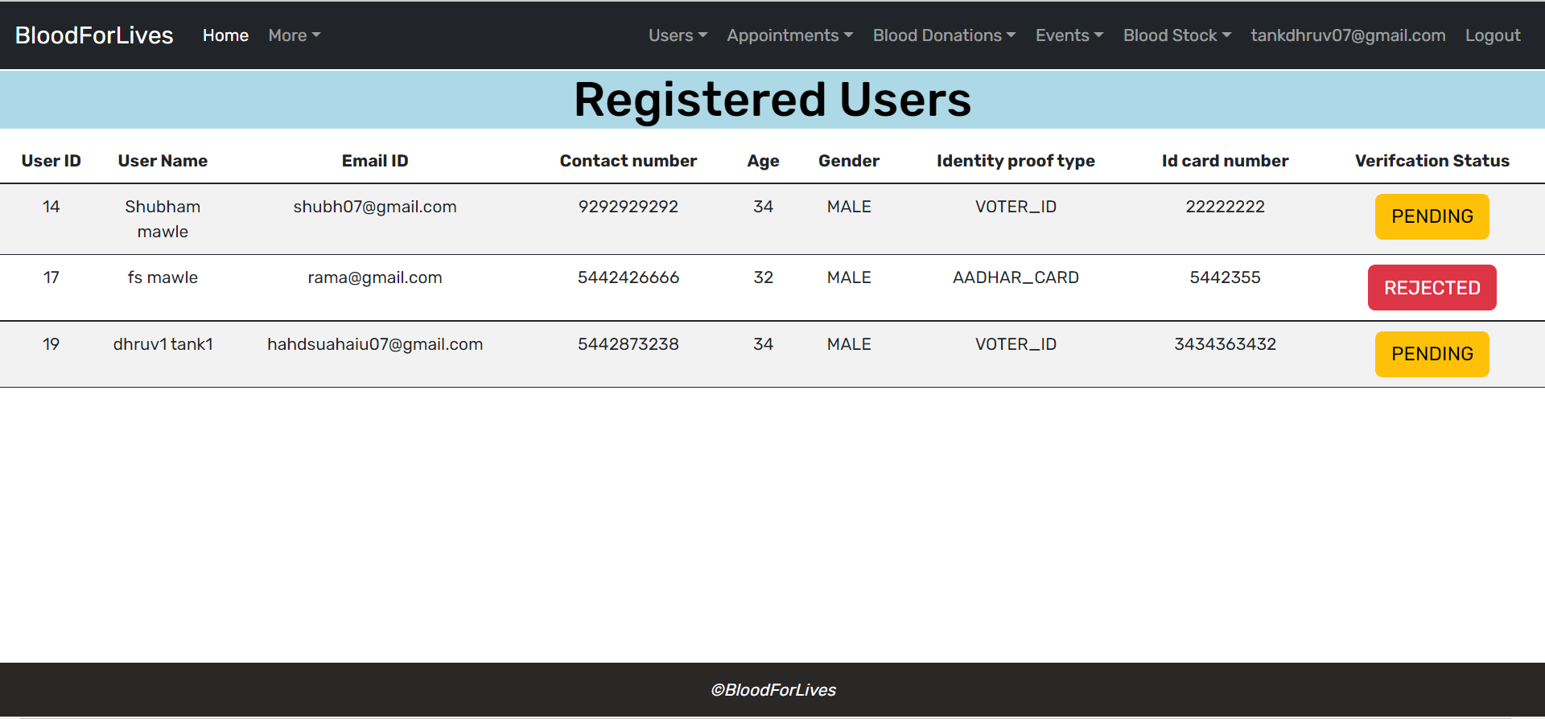**

# CONCLUSION

The project entitled “**E-Blood bank”** was completed successfully.

The system has been developed with much care and free of errors and at the same time it is efficient and less time consuming. The purpose of this project was to maintain patient records efficiently and securely for future use.

This project helped us in gaining valuable information and practical knowledge on several topics like designing web pages using React.JS, usage of responsive templates, designing of android applications, and management of database using MySQL. The entire system is secured. Also, the project helped us understanding about the development phases of a project and software development life cycle. We learned how to test different features of a project.

This project has given us great satisfaction in having designed an application which can be implemented to blood banks.

Blood banks administrators would be able to significantly improve the operational control and thus streamline operations. This would enable to improve the response time to the demands of donor and consumer because it automates the process of collecting, collating and retrieving user’s information

There is a scope for further development in our project to a great extent. A number of features can be added to this system in future like combining hospitals with this project. Also making dashboard more user’s friendly. Also generate blood donation certificate.

# REFERENCES

1. JavaScript Enlightenment, Cody Lindley-First Edition, based on JavaScript 1.5, ECMA-262, Edition
2. Mc Graw Hill’s, Java: The complete reference 7thEdition, Herbert Scheldt

1. Complete CSS Guide, Maxine Sherrin and John Allsopp-O'ReillyMedia; September 2012
2. Ali Bahrami, Object-Oriented System Development, Third Edition, Tata McGraw Hill Edition

**ONLINE REFERENCE**

* 1. [www.Google.com](http://www.google.com/)
  2. [www.w3school.com](http://www.w3school.com/)
  3. [www.javatpoint.com](http://www.javatpoint.com/)
  4. [https://docs.spring.io/spring-framework/docs](https://docs.spring.io/spring-framework/docs/current/reference/html/)
  5. https://getbootstrap.com/docs/4.0